Integration: area under the curve , if u solve the integral with the help of calculator, the value u achieve at the end as resultant would be called as analytical result.

1. Trapezoidal rule (calculation not included ) (less efficient) slower
2. Simpson’s 1 /3rd Rule: included (more efficient) faster

Both the above methods have been designed to find out the approximated value of integrals

Simpson’s 1/3rd rule:

**dx** = h/3 [(y0+yn) + 4(y1+y3+y5+….+yn-1)+2(y2+y4+y6+…..+yn-2)]

Where n is the even number, △x or h = (b – a)/n is the number of intervals used in simpson’s or trapezoidal rules. **(works with even number of n)**

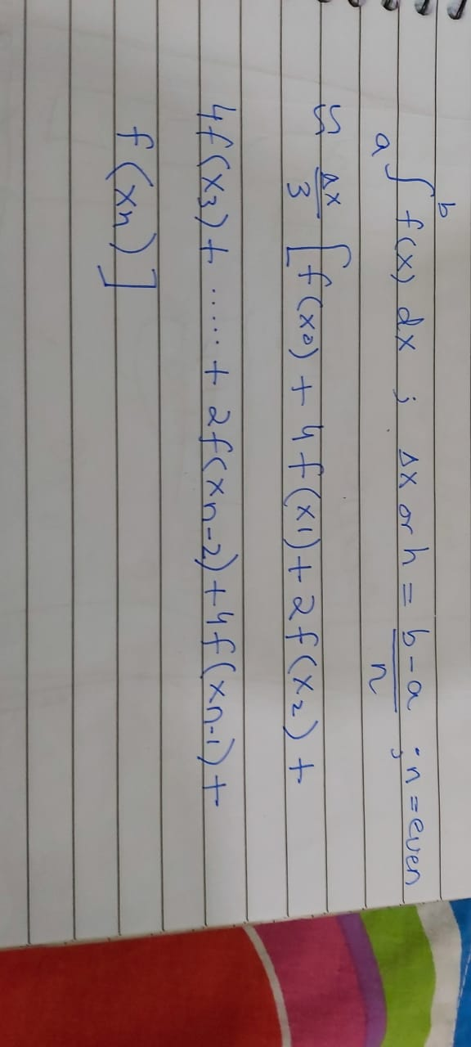

a) Given the integral as $\int_{0}^{3}{\frac{1}{1+x^{5}}}$ dx. Find out the approximated value of the given integral using Simpson’s 1/3rd rule.

b) find out the accuracy of the approximated value. We need True value, approximated value to find any sort of error to find the accuracy

(true/real value) 1.06587

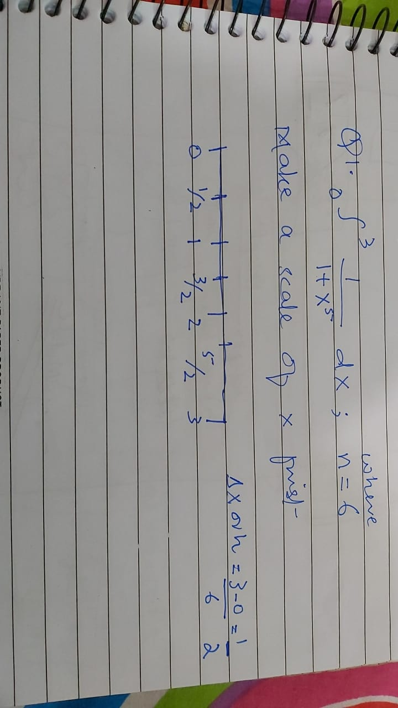

Ans : 1.074915